COMP 8006 Assignment 1

Table of Contents
Usage 2
Design 2
Psudocode 2
Testing 2
Nmap 2
DNS + WWW 3
Hping - inbound traffic to port 80 (http) from source ports less than 1024 3

Usage
> ./ez-firewall.sh

Design

Psudocode
Flush all chains
Delete all user chains
Set default policies to DROP for all chains
Create user chain for ssh
Create user chain for www
Drop all packets from port 0
Drop all packets to port 0
Drop inbound traffic to port 80 from source ports 0 to 1023
Jump all packets to and from ports 80 and 443 to www chain
Jump all packets to and from port 22 to ssh chain
Accept all packets to and from port 53
Accept all packets to www chain
Accept all packets to ssh chain

Testing
Testing done with test.sh
Rule # | Test Description | Tool Used | Expected | Pass/Fail
1 | Inbound to port 22 | nmap | Packets received from nmap test | Pass
2 | Connect to port 80 from another machine to your machine with a source port that is greater than 1024 via hping (Inbound/Outbound Web Traffic). | Chrome + iptables | http://www.webscantest.com | Pass
3 | Deny packets connecting to port 80 with a source port less than 1024 | Hping | 10 SYN packets sent and dropped | Pass
4 | Accept packets from port 443 | Chrome + iptables | Google.ca is loaded and rule hits incremented | Pass

Usage:
> ./test.sh &> <filename>

Nmap
Used for testing inbound packets to port 80,443,53,22,0 with both tcp and udp Protocol
# Nmap done at Mon Jan 29 13:43:50 2018 -- 1 IP address (1 host up) scanned in 1.51 seconds
# Nmap 7.60 scan initiated Mon Jan 29 13:46:09 2018 as: nmap -oA results --append-output -p 80,443,53,22,0 192.168.0.5
Nmap scan report for 192.168.0.5
Host is up (0.00028s latency).

PORT STATE SERVICE
0/tcp filtered unknown
22/tcp filtered ssh
53/tcp closed domain
80/tcp closed http
443/tcp closed https
MAC Address: 98:90:96:DC:EB:26 (Dell)

DNS + WWW
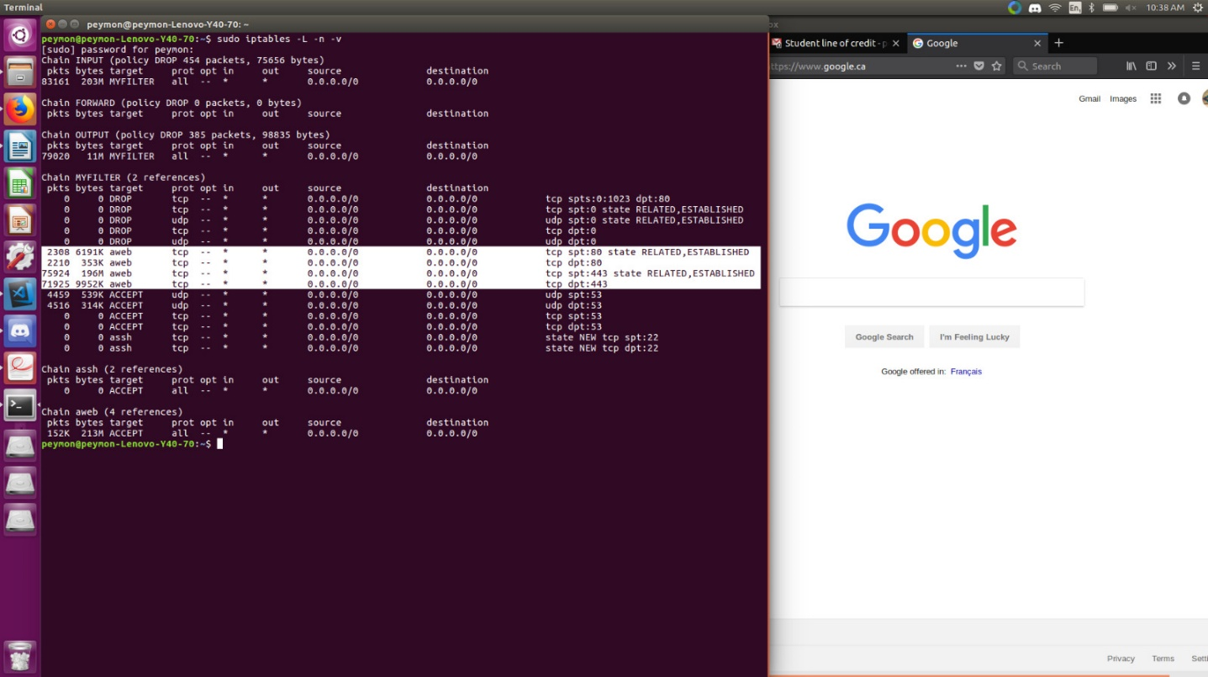

Hping - inbound traffic to port 80 (http) from source ports less than 1024
--- 192.168.0.5 hping statistic ---
10 packets transmitted, 0 packets received, 100% packet loss
round-trip min/avg/max = 0.0/0.0/0.0 ms
HPING 192.168.0.5 (eno1 192.168.0.5): S set, 40 headers + 0 data bytes

